Chapter 1:

Introduction

Voting whether conducted through the traditional ballot or via electronic means forms the basis on which democracy depends Electronic Voting has taken center place in research with the intention of minimizing the cost associated in setting up the voting process, while ensuring the electoral integrity is maintained by fulfilling privacy, security and compliance requirements. The current method, whether electronic or not has proved to be unsatisfactory with respect to transparency. It can be very difficult for the voters to be assured that the vote he/she has casted during the election reflects in the election result. Electronic voting using Direct Recording Electronic do not generate receipt on successful casting of votes. No record of election except vote count is made public by the government, which means that the voters are not assured of any external interference in case of government conducting the process of vote recounting. Non-governmental entities can also interfere with elections, through physical force, verbal intimidation, or fraud, which can result in improper casting or counting of votes. Monitoring for and minimizing electoral fraud is also an ongoing task in countries with strong traditions of free and fair elections. Replacing the traditional method with electronic method using Blockchain technique can prevent potential frauds that may take place during election.

**Blockchain technology** is a distributed network of interconnected nodes. A copy of distributed ledger is assigned to each node, each of which contains a complete history of all the transactions that have been processed by the network. Each transaction processed generated a hash. The hash created depends not only on the current transaction but also on the hash of the previous transaction. Thus, any small change on the data will impact the hash of the transaction. The transaction is written to the block. This allows the users to remain autonomous while using the system. A basic analysis of Blockchain suggests that it provides the potential of making the voting process more secure and reliable.

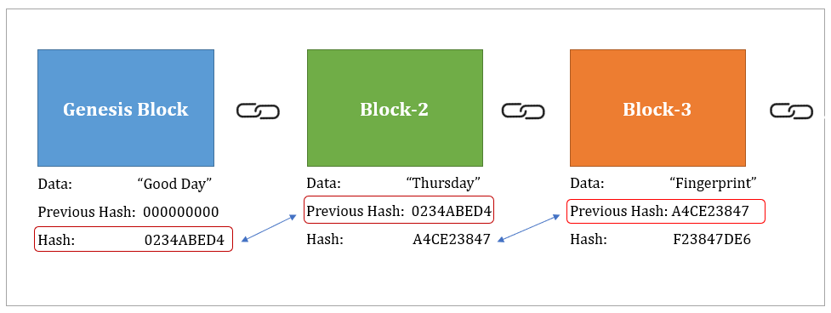

Fig:2.1: Block Chain Diagram

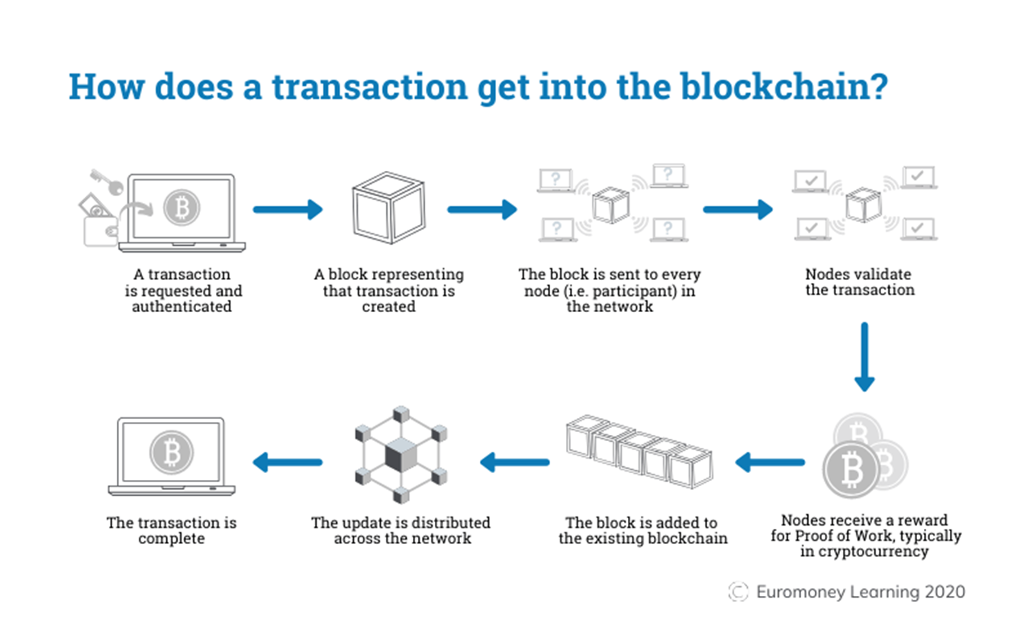

Fig:2.2: How does a transaction get into the blockchain

Chapter 2:

PROBLEM DEFINITION

* Election has a very major role in democracy because it is the deciding factor of the future of a country, but the major concern is that society does not trust the election system.
* The issue with the current ballot voting system is that it can be easily manipulated by power hungry organizations.
* Flawed electoral system is the issue faced by even the world’s largest democracies like India, United States, and Japan.
* The major issues that need to be addressed in the current voting system are vote rigging, EVM hacking, polling booth capture and election manipulation.
* The current method, whether electronic or not has proved to be unsatisfactory with respect to transparency.
* Electronic voting using Direct Recording Electronic do not generate receipt on successful casting of votes.
* No record of election except vote count is made public by the government, which means that the voters are not assured of any external interference in case of government conducting the process of vote recounting.

Chapter 3:

EXIXTING SYSTEM / LITERATURE SURVEY

* **Online Voting System for India Based on AADHAR ID - Himanshu Agarwal, G. N. Pandey in the year 2013.** A high security password is checked in the main database before voting is allowed. The voter will be able to confirm if the vote is transferred to the correct candidate or party. The tallying of the votes can be done manually, thus saving the data.
* **Biometric voting system using Aadhaar card in India – S Chakraborty, S Mukherjee in the year 2016.** The main goal of this venture is to build a safe electronic voting machine using Finger printing technique that distinguishes evidence, so that we can use the Aadhar card database for specific marks. The online-voting confirmation process should be possible during the race voting season using finger vein detection, which enables the electronic poll reset to allow voters to cast their votes.
* **Trustworthy Electronic Voting Using Adjusted Blockchain Technology - Basit Shahzad Raju, Jon Crowcroft in the year 2019**. This paper suggests a system that makes use of appropriate hashing methods to ensure data security. This paper introduces the concept of block-creation and block sealing. The implementation of a block sealing principle helps to make the blockchain flexible to meet polling process requirements.
* **Security Analysis of India’s Voting Machine - Hari K. Prasad, Arun Kankipati, Sai Krishna Sakhamuri in the year 2010** . Security Analysis was performed on real Indian EVM system. This paper states that EVM can be tampered in many ways such as, tampering with software before CPU manufacture, tampering with machine state, substituting a look a-like CPU and/or a unit and thus secrecy of the ballot can be violated. The proposed voting system does not have any major hardware requirements, thus elimination all the above disadvantages of EVM. Also the proposed model uses blockchain which ensures that the vote transfer to candidate’s ballot is easy and secure.

Chapter 4:

PROBLEMS OF EXIXTING SYSTEM

E-voting system might face following problems:

* **Anonymous vote-casting:** Each vote may or may not contain any choice per candidate, should be anonymous to everyone including the system administrators, after the vote is submitted through the system.
* **Individualized ballot processes**: How votes are depicted within the involving of net applications or databases continues to be an open discussion.
* **High initial setup costs:** Though sustaining and maintaining on-line selection systems is way cheaper than ancient elections, initial deployments could be pricy, particularly for businesses.
* **Increasing security problems:** Cyber-attacks cause an excellent threat to the general public polls. Nobody would settle for the responsibility if associate degree hacking try succeeds throughout an election.

Chapter 5:

PROPOSED SYSTEM

* In this system the voter/**user must first register themselves** using a registration form available within the web application and once the registration form is being submitted, an entry is made in the blockchain.
* After the registration, the user can log into the application and be a part of the polling process. The user with valid credentials can log into the system by entering their Aadhar number and password.
* Once the user is logged into their respective account the dashboard contains all the information about voting.
* When user click on the vote menu, they will see the candidates of the respective parties.
* User will select a one party and cast the vote for that party. Only one vote is casted from each account.
* Once the vote is cast that account is registered into the blockchain.
* The system has a secure login system which prevents people from casting votes on behalf of others.
* By clicking the result menu user can see the result on the dashboard.
* Dashboard also contain admin panel only accessed by the admin; the admin can add new candidates into the system and see the user’s name with its valid credentials.

Chapter 6:

ADVANTAGES OF PROPOSED SYSTEM

Here are the advantages of conducting e-voting via blockchain:

* Enhanced security as voting takes place over secure communication channels.
* Low cost of setup as only the internet connection cost is required to vote across all the available e-voting platforms.
* Accurate results and speed in the vote count.
* Fraud prevention due to less human intervention at the polling stations.

Chapter 7:

Fig:7.1: Block Diagram

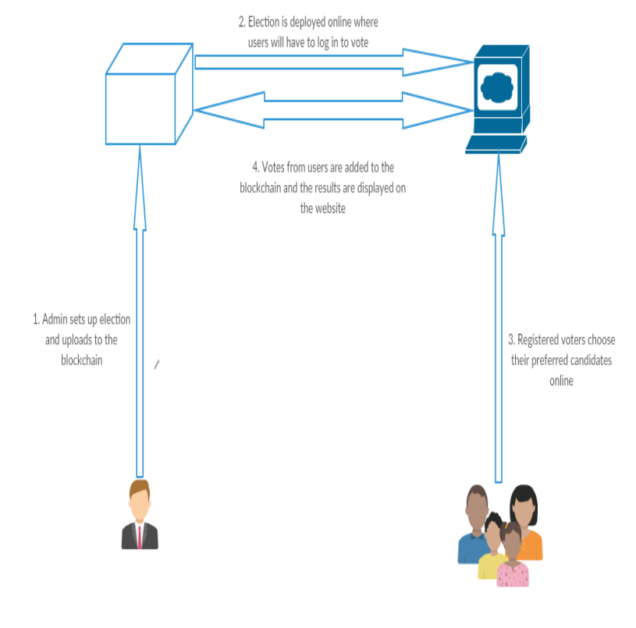

Fig:7.2: Conceptual Diagram

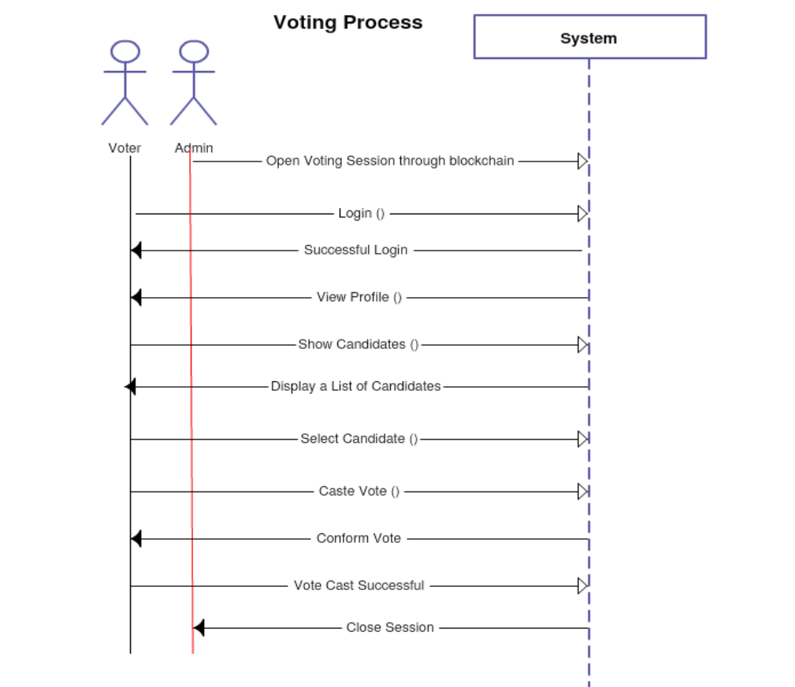

Fig:7.3: Sequence Diagram

Chapter 8:

SYSTEM REQUIREMENTS

8.1: SOFTWARE REQUIREMENTS

|  |  |  |
| --- | --- | --- |
| Software | Type | Version |
| Windows | Operating System | 7 or above |
| Visual Studio | Framework | 1.76 |
| Ganache | Ethereum Blockchain Server | 2.4.0 |
| MetaMask | Ethereum Wallet | 7.7.9 |
| Truffle | Development framework for ETH | 5.1.31 |
| Localhost | Server |  |

8.2: HARDWARE REQUIREMENTS

1. Processor: Intel Quad core 1.7 GHZ Processor or above.
2. HD: Minimum 10 GB of HD.
3. RAM: Minimum 4 GB of RAM

Diagrammatic Representation:

MetaMask first asks the user to connect their project to blockchain

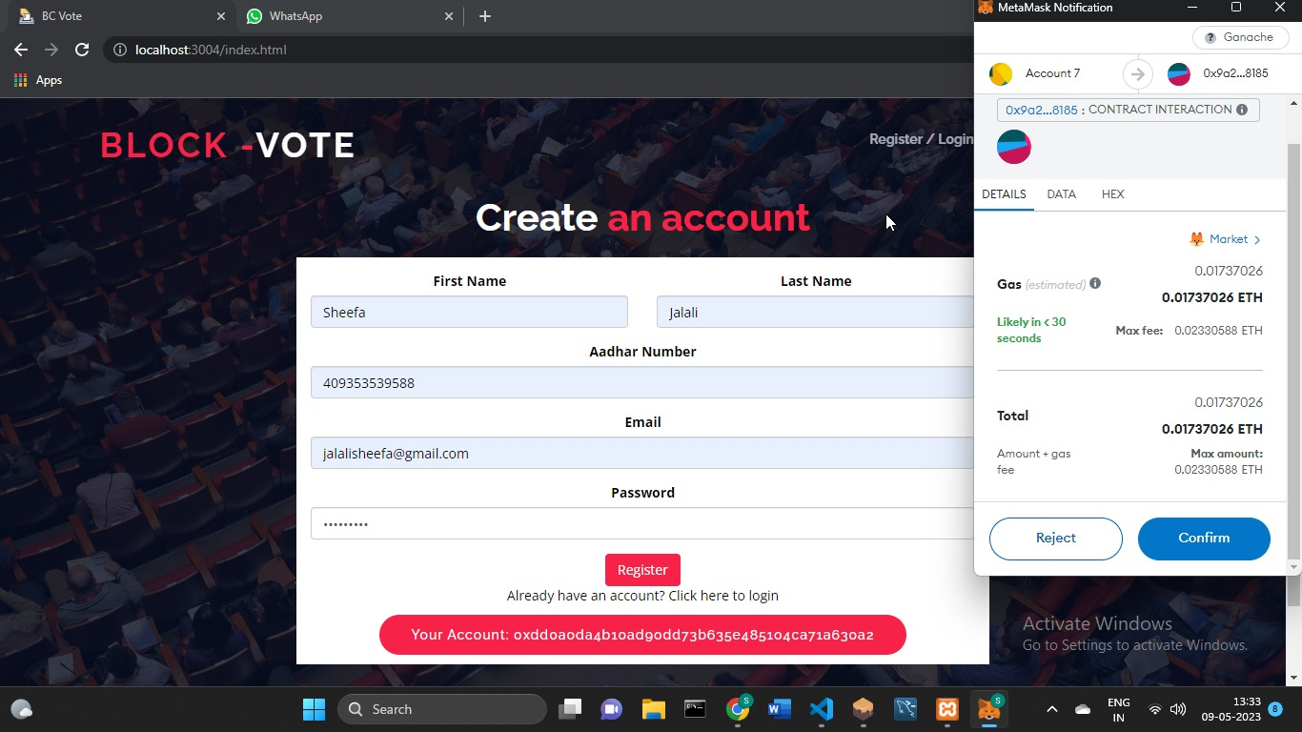

Once the user is connected, the admin can now set up the election that is add candidates and start and end the election.

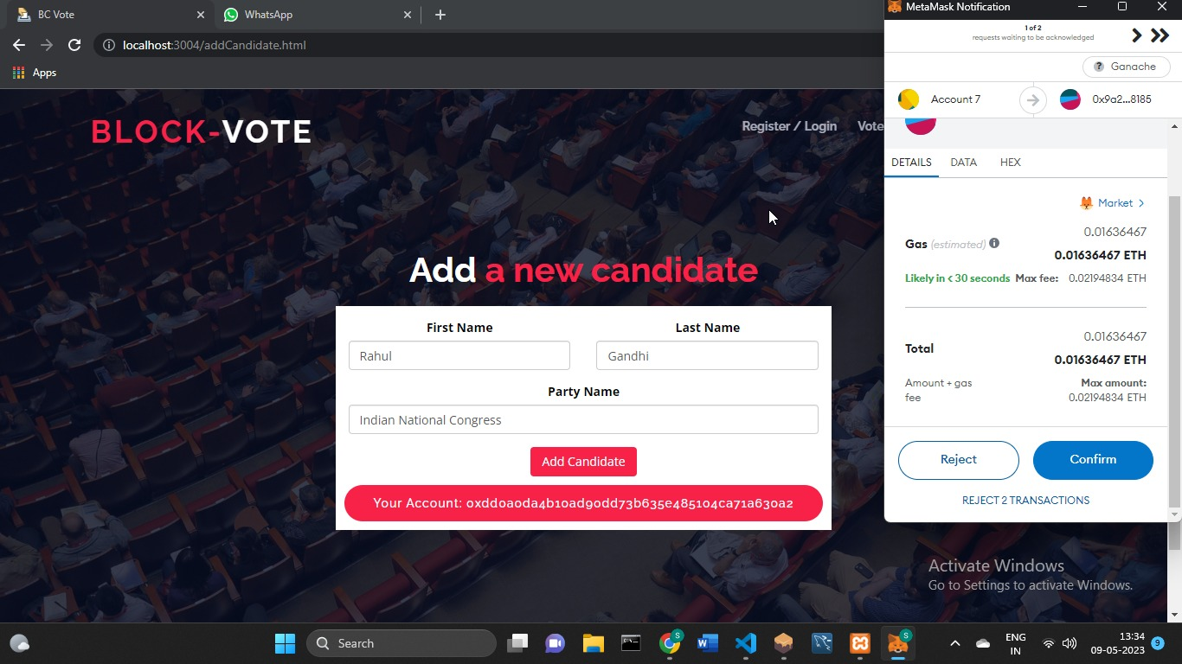

The admins can also view the election details such as vote tally and voters’ details.

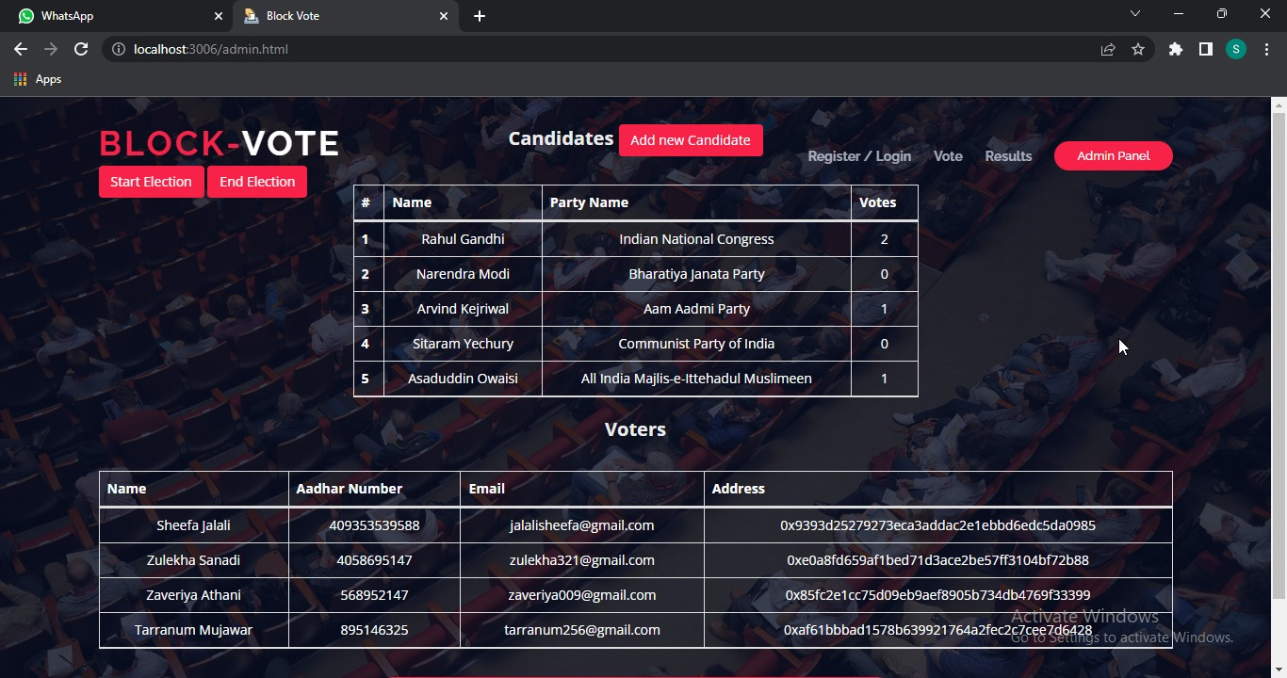

Once the voting process is deployed voters can register for the voting process.

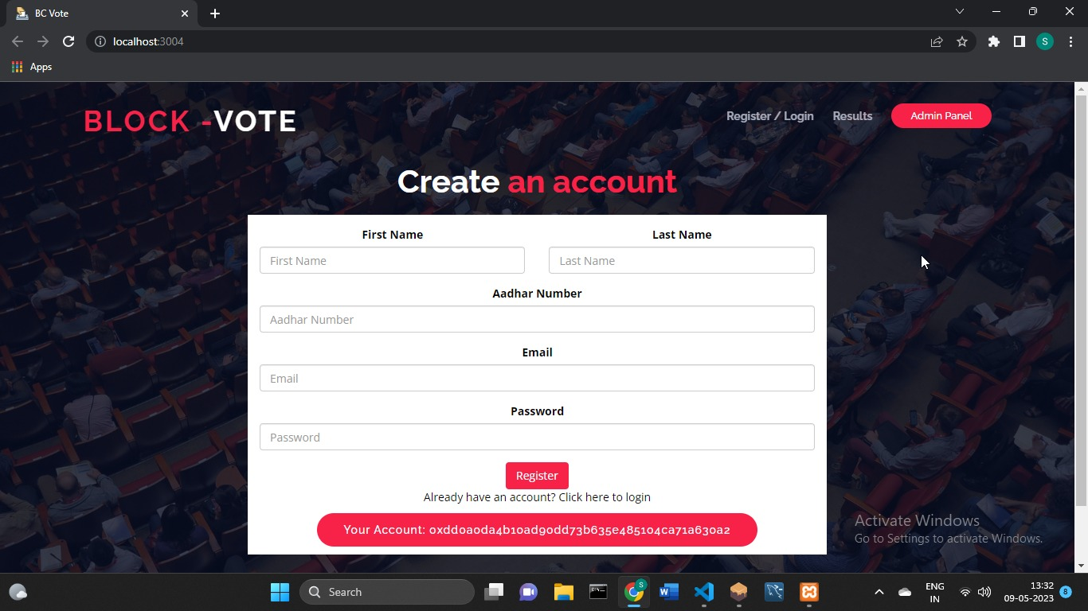

Voters will the cast their vote by choosing their preferred candidate.

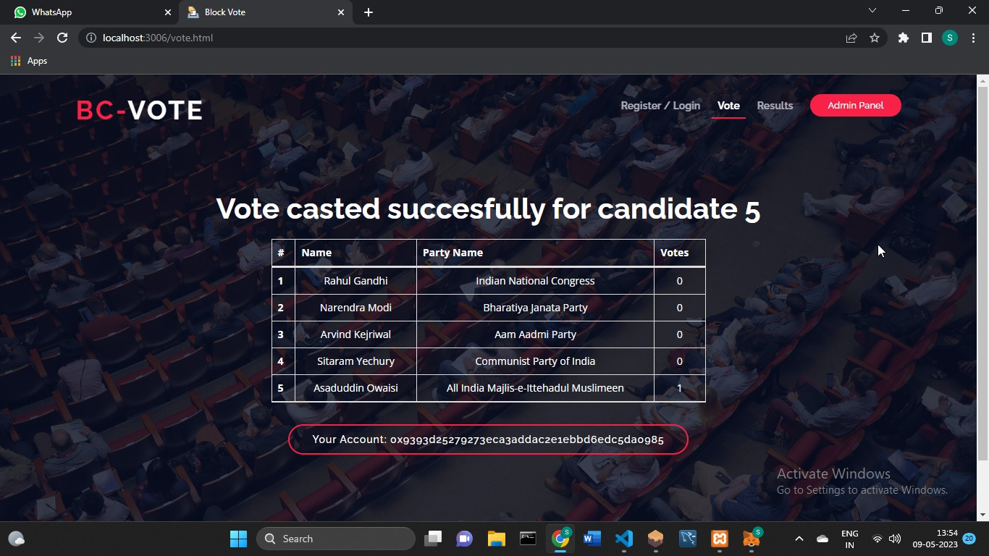

Results page

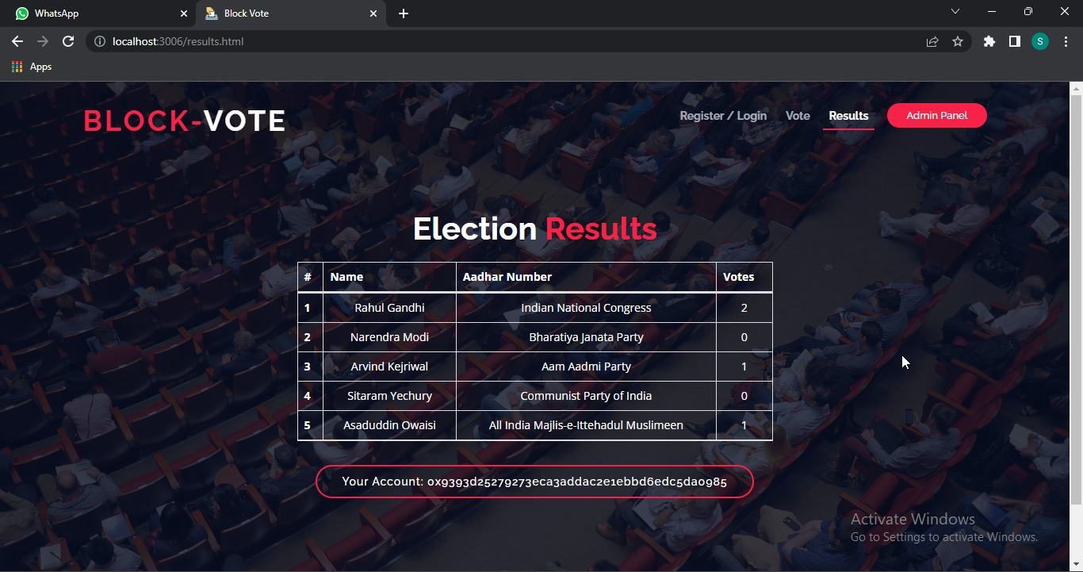

Chapter 9:

TESTING

Testing refers to examining the software system to identify errors and ensure that the system meets the requirements specifications. The approach in this case includes the Module testing and Integration System Testing. The module testing involved examining the memory dump of the program and using web console of the development browser. This technique was used to test each independent unit for proper functioning.

9.1 Integration

The individually tested modules were integrated and tested together and errors and bugs collected and corrected.

9.2 System Testing

The entire system was tested and sample data was input to ensure the proper working of the system and that it meets the requirements of the system and that it is error free

9.3 Software Testing

Test Case Matrix for the System

|  |  |  |  |
| --- | --- | --- | --- |
| Test Case | Expected Results | Actual Result | Pass/Fail |
| Login In (Positive Match) | Should positively identify a user and redirect to a dashboard with specific rights that are appended to the user. | Positively identifies a user and redirects to voting page with information about the user. The user also is granted specific rights depending on level of access. | Pass |
| Login In (Negative Match) | Should decline login request and display a reason why the request was declined. | Declines login request and displays the reason why the request was declined. | Pass |
| Add candidate | Should be able to add candidate into the voting process | Candidate details are displayed in the voting page where voters can choose. | Pass |
| Vote | Should able to cast a vote for the preferred candidate. | Voters select their preferred candidate and click on vote. That candidates vote count increases by 1 | Pass |
| Check results | Should accurately show the tally of all the votes casted. | Once someone casts their vote they are taken to the results page which shows a real time vote tally | Pass |
| Cannot vote twice | Should prevent users from casting a second vote once they have already voted. | The select candidate option and vote button disappears once a candidate has casted their vote. | Pass |

Chapter 9:

FEATURES PROVIDED BY THE SOFTWARES**:**

9.1 GANACHE:

Ganache is a development tool in the Truffle Suite and is used for setting up a personal Ethereum Blockchain to deploy contracts, develop your applications, and run tests. It

consists of details of the transaction such as hash value (Txn Hash), block number of the

transaction, and transaction fee (Txn Fee), from address and to address.

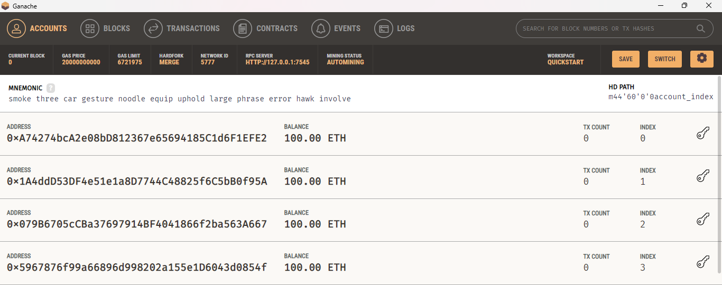

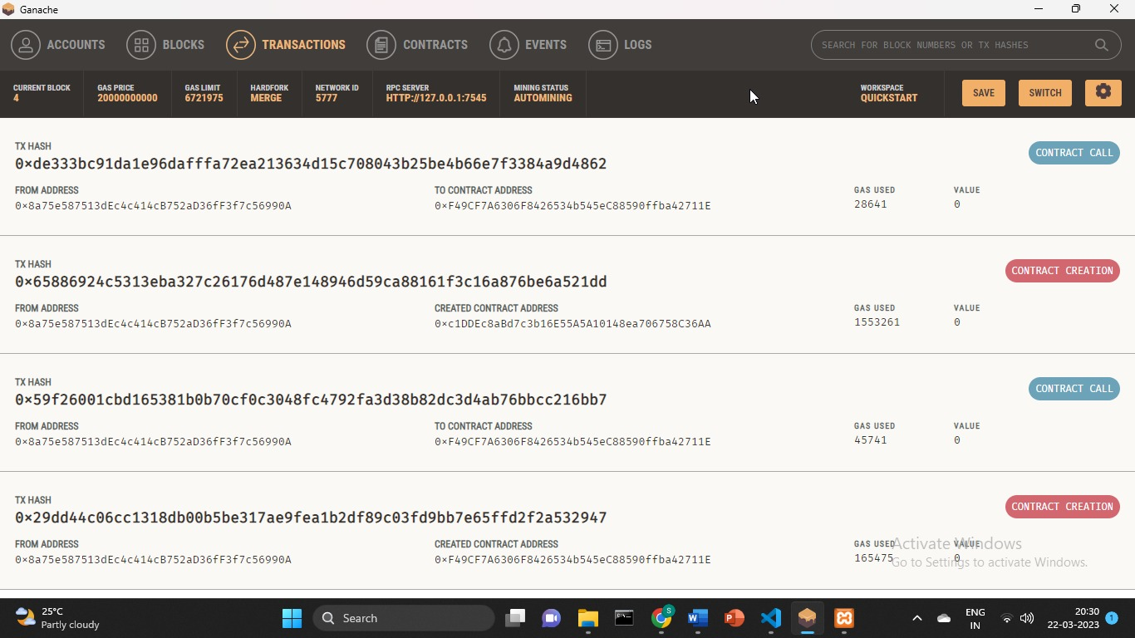

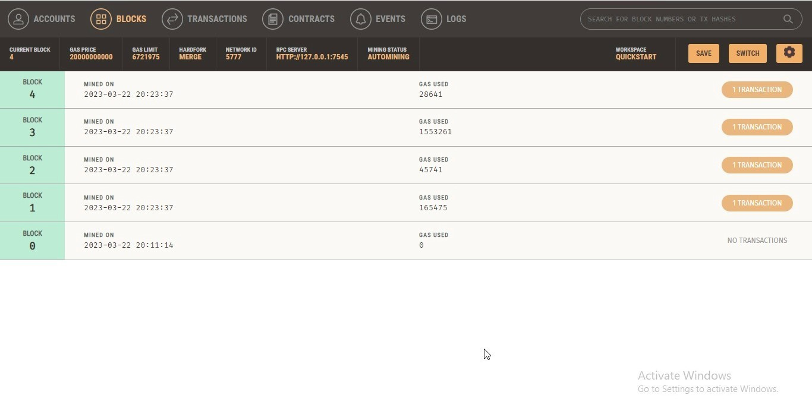

9.2 TRUFFLE:

Truffle is a development environment utilizing the EVM (Ethereum Virtual Machine) as a basis. The environment specializes in smart contract development. This environment features several great functionalities that help App developers and is used to deploy/execute the smart contracts.

9.3 METAMASK:

MetaMask is a software cryptocurrency wallet used to interact with the Ethereum blockchain. It allows users to access their Ethereum wallet through a browser extension or mobile app, which can then be used to interact with decentralized applications.

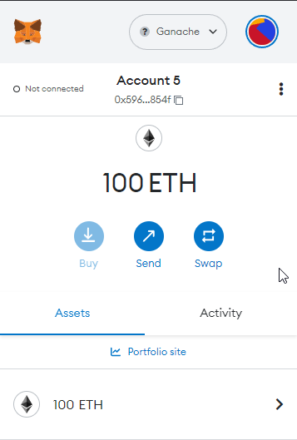

Chapter 10:

SOURCE CODE

10.1: Election.sol

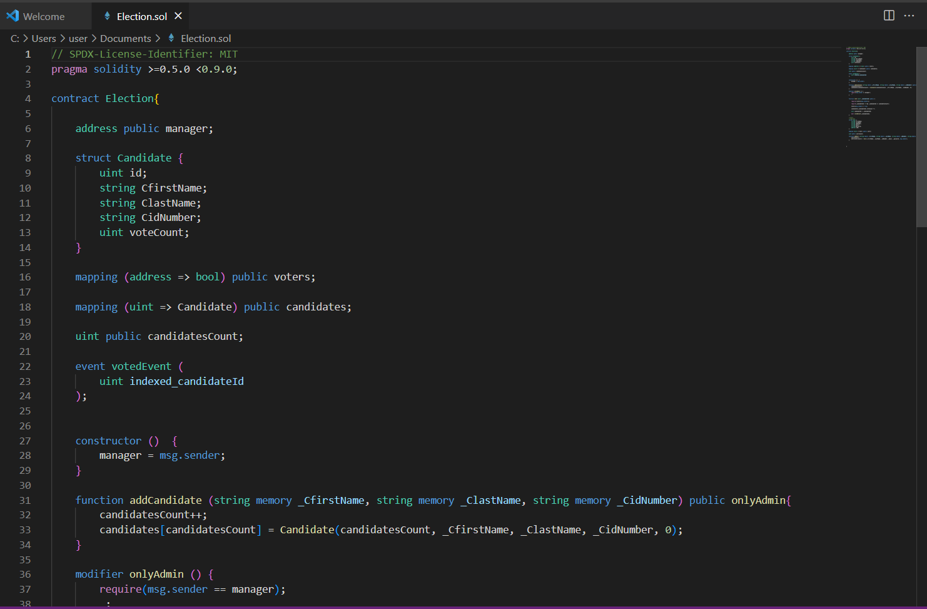

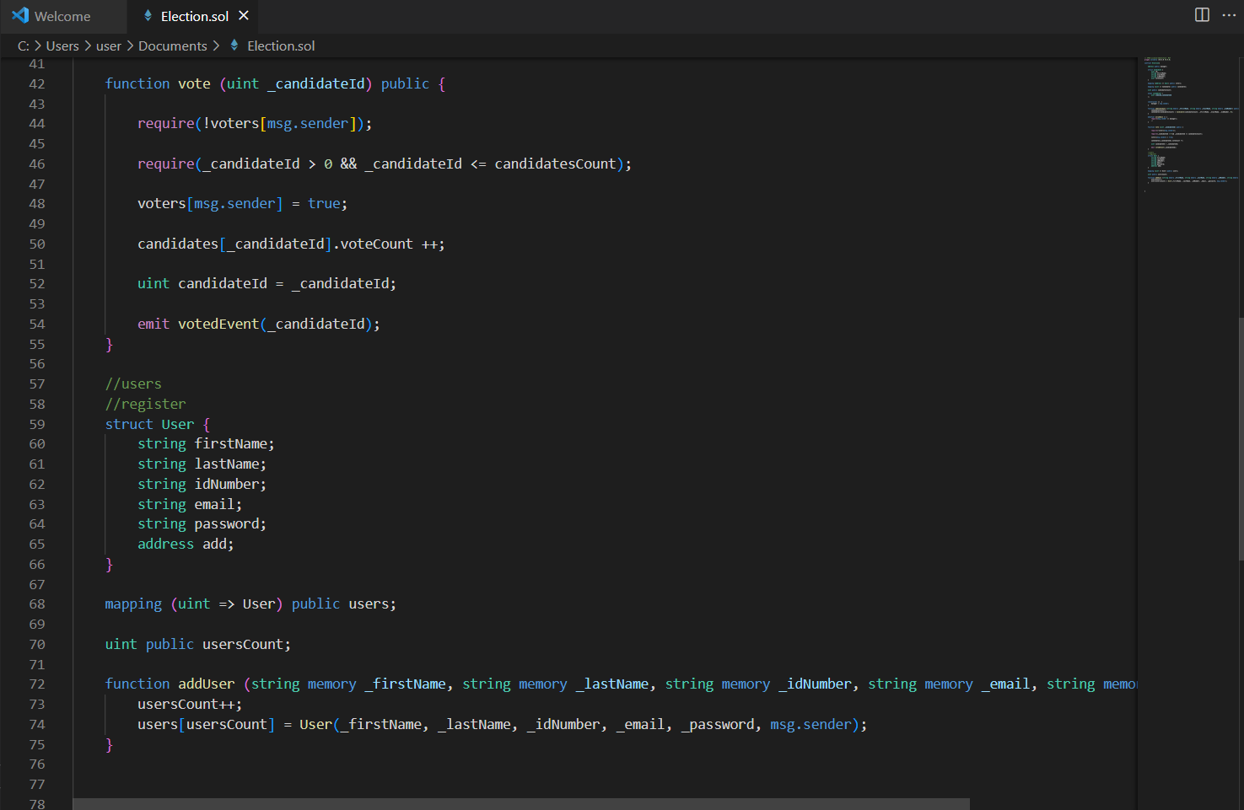

10.2: Migrations.sol

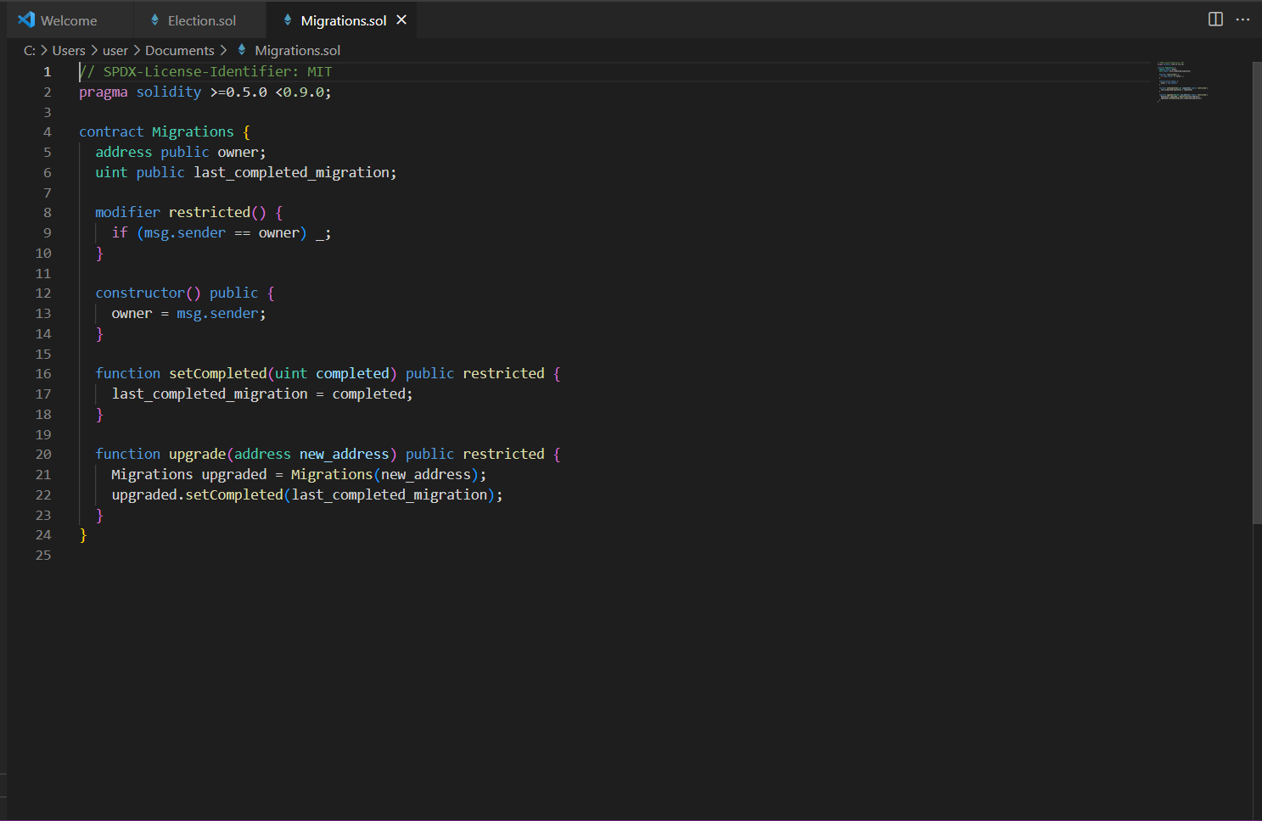

10.3: APP.js

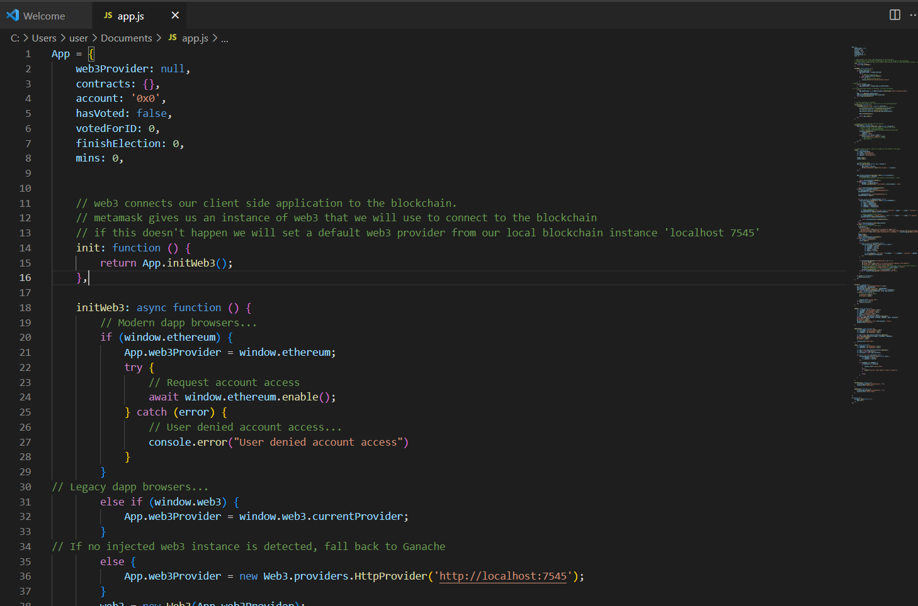

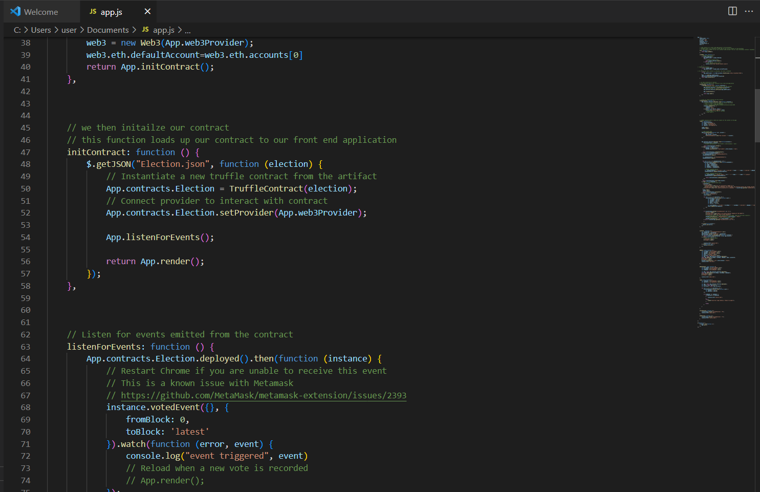

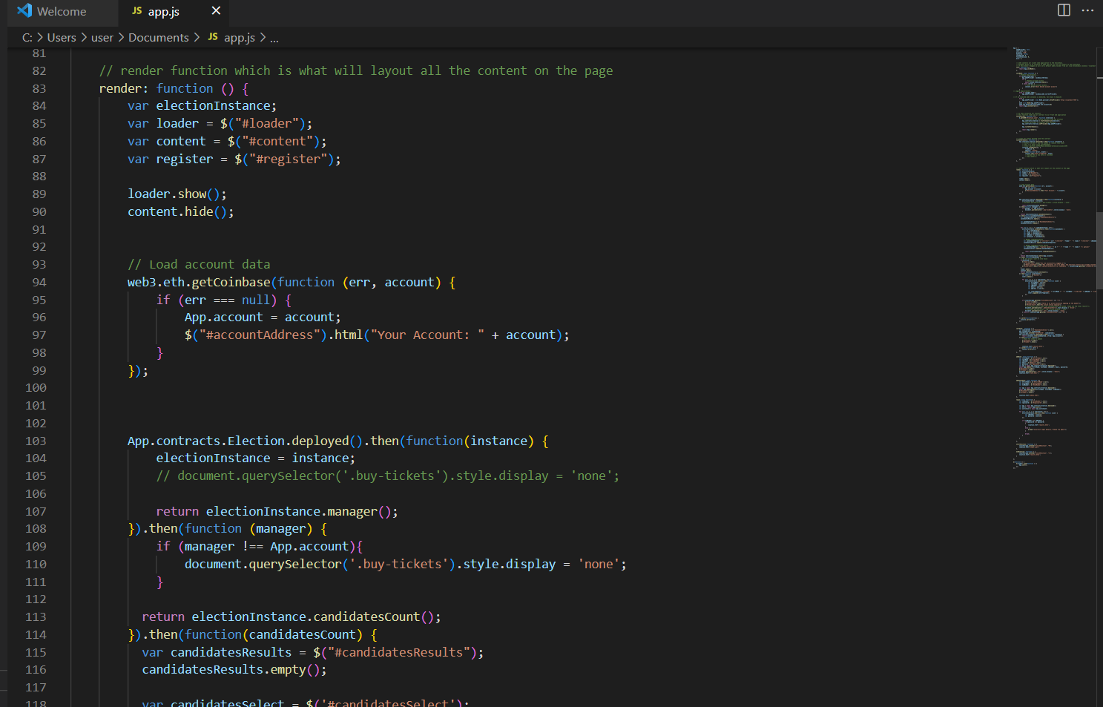

10.4: addCandidate.html

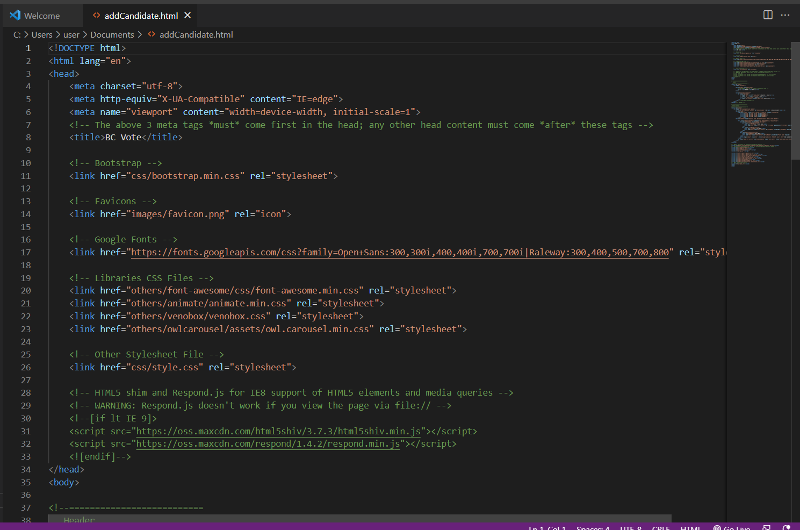

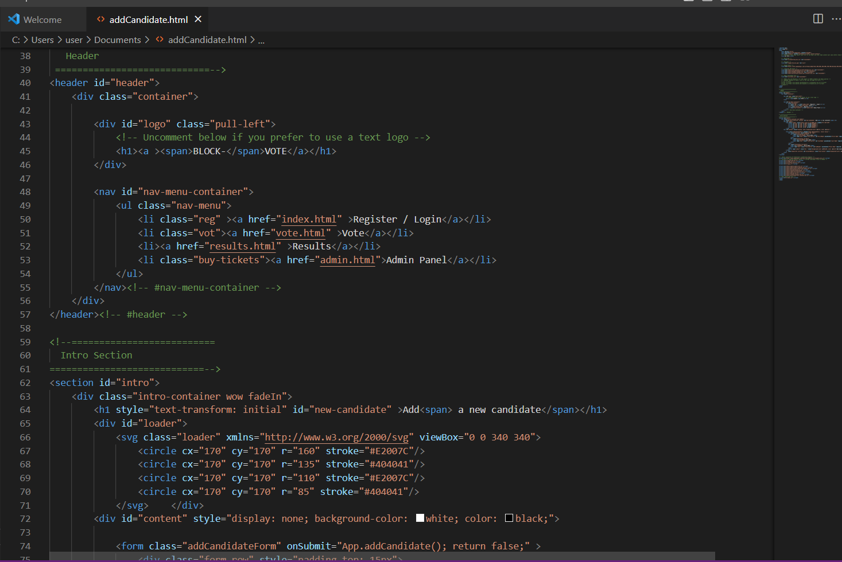

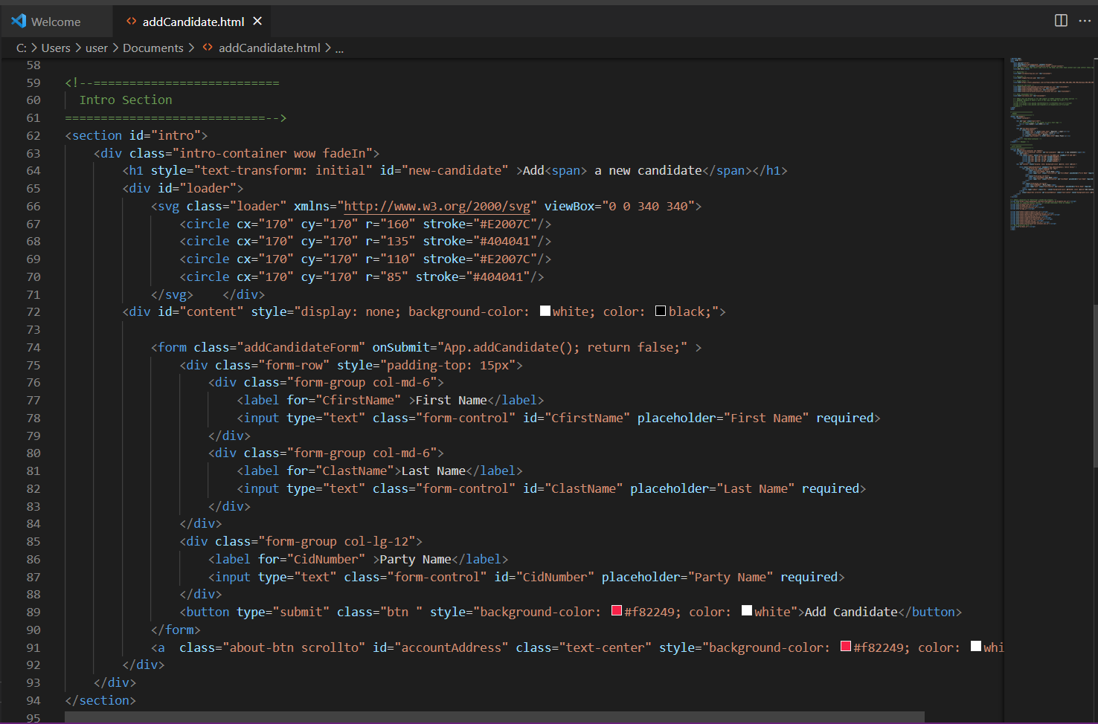

10.5: admin.html

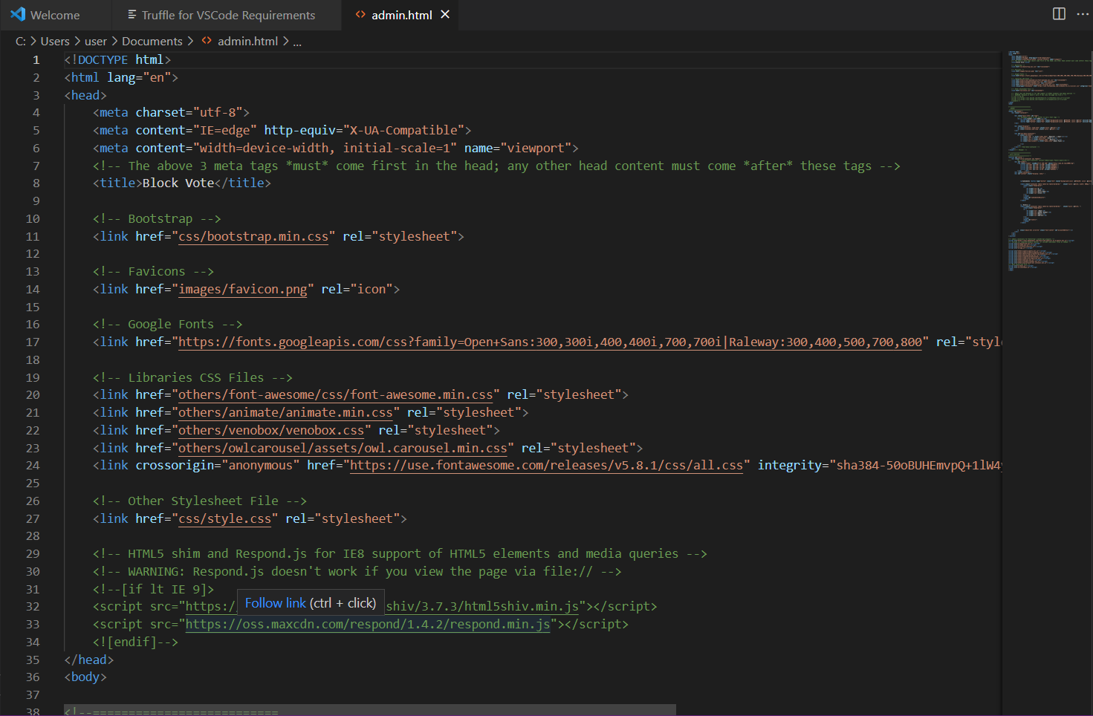

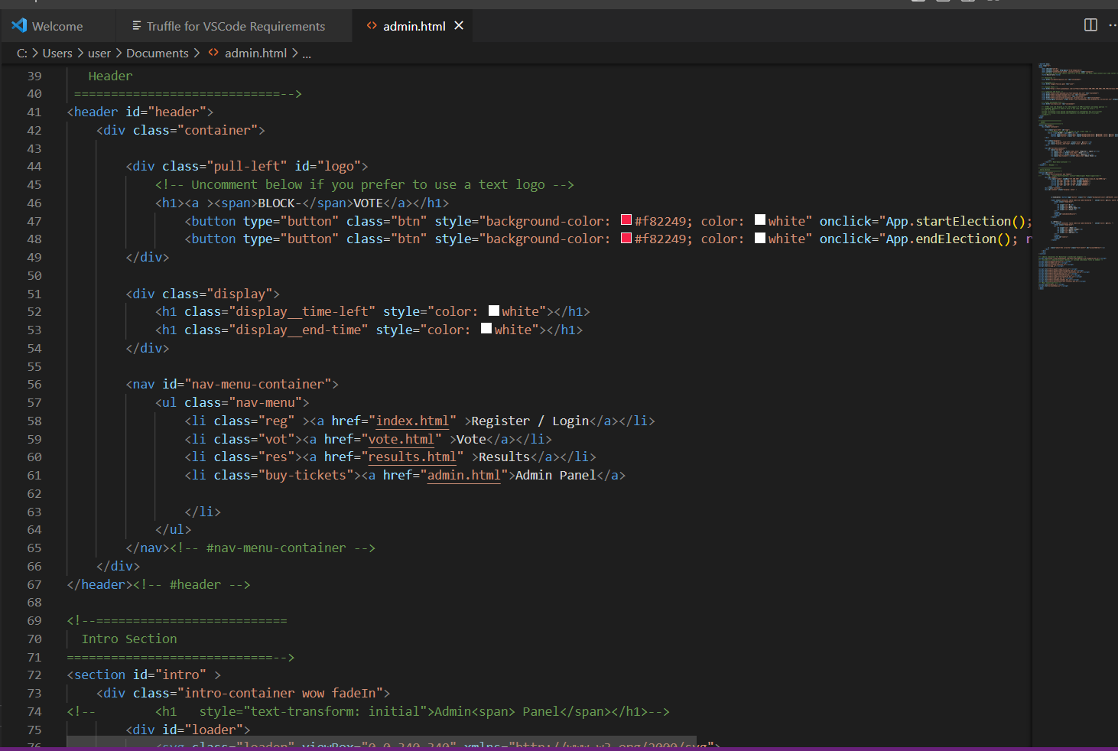

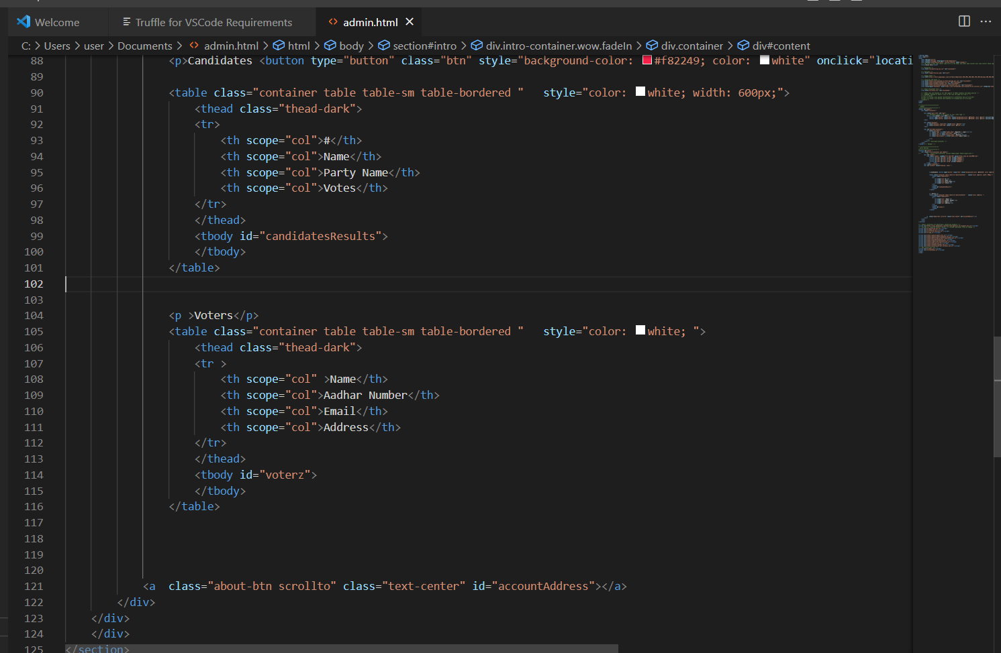

10.6: index.html

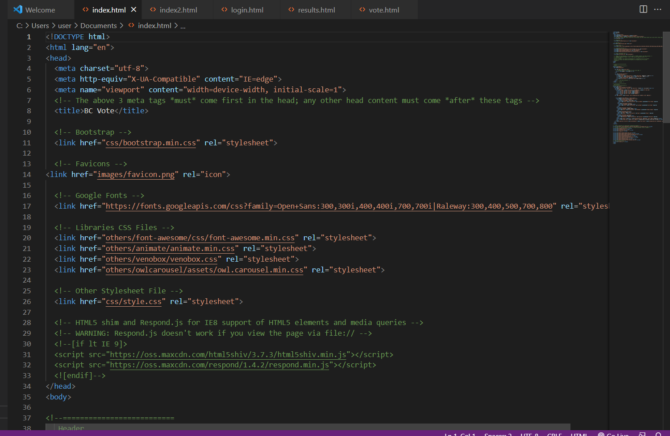

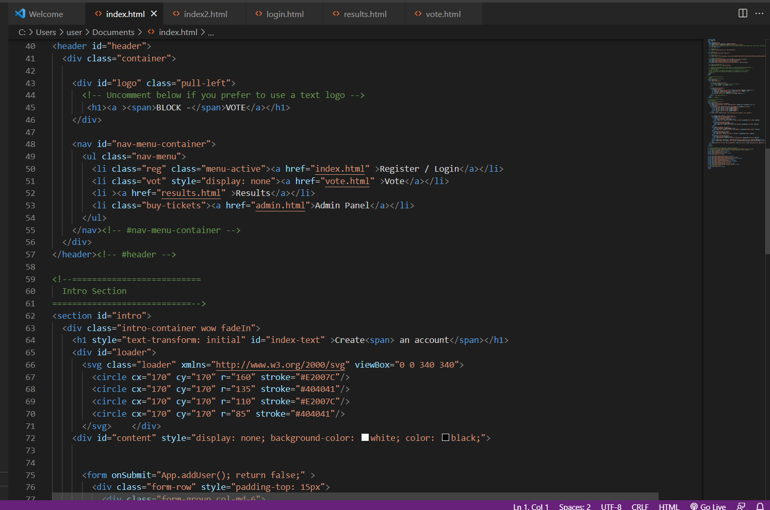

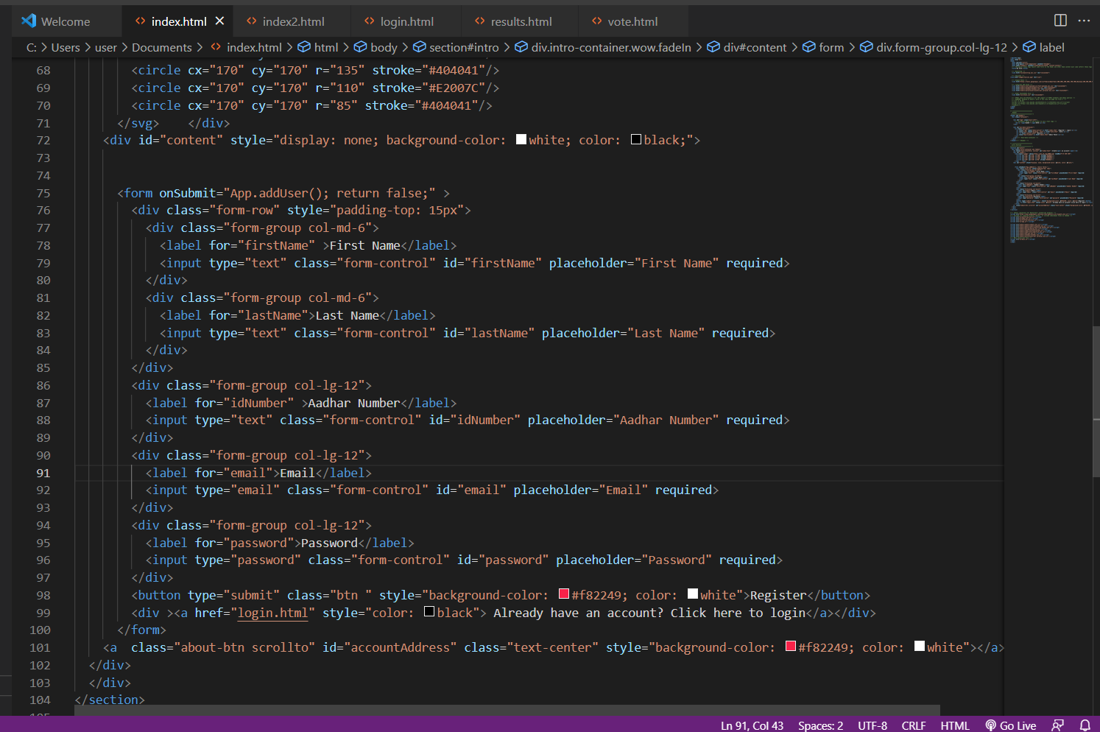

10.7: index.html

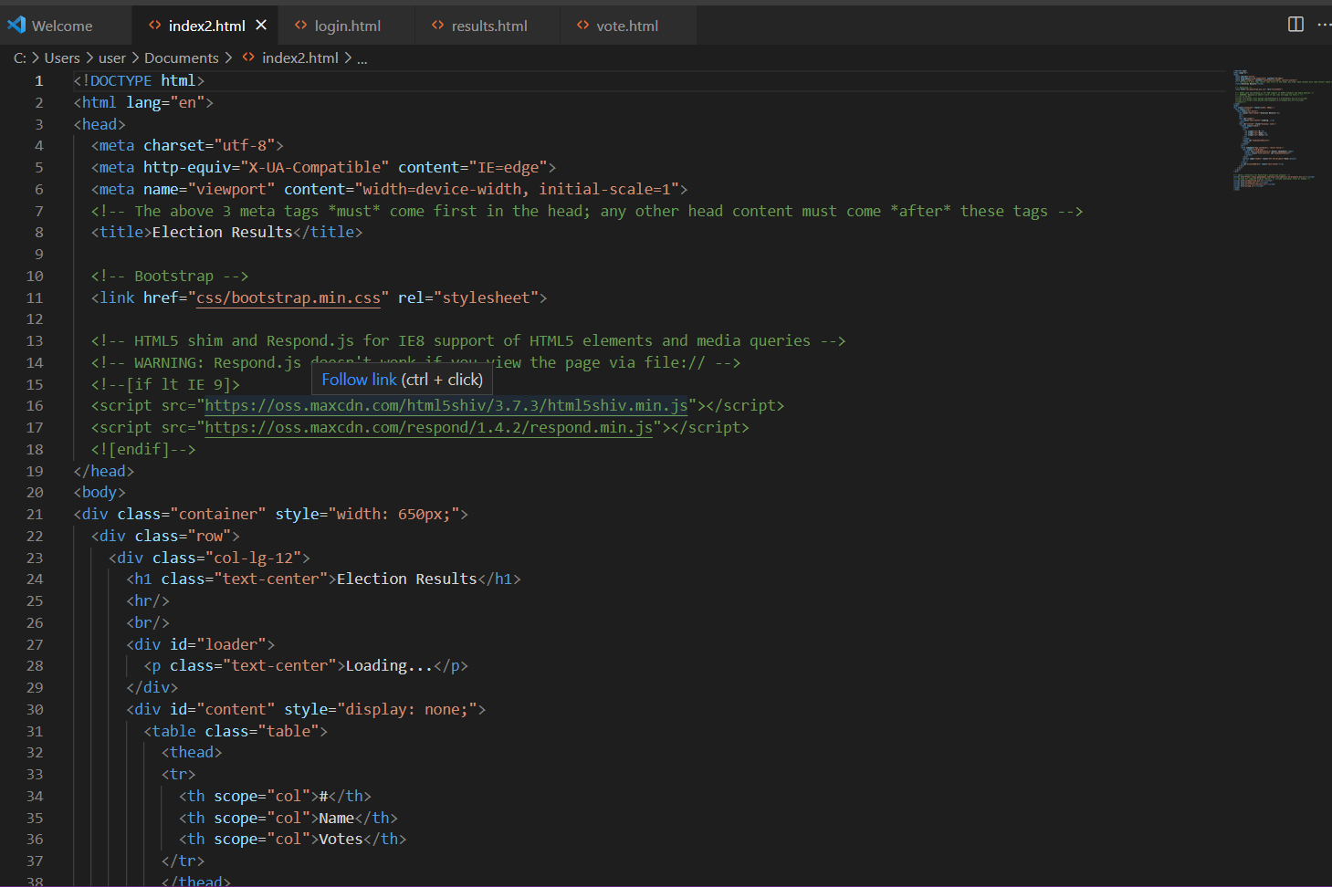

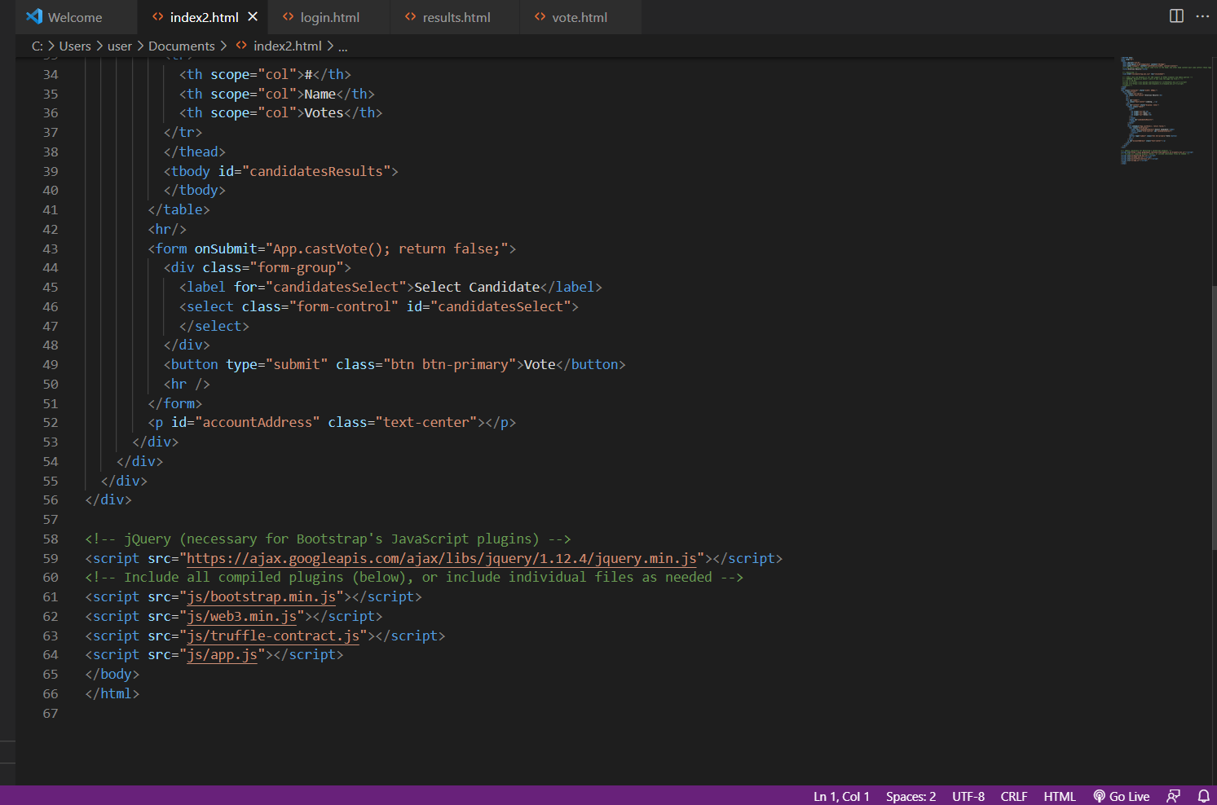

10.8: login.html

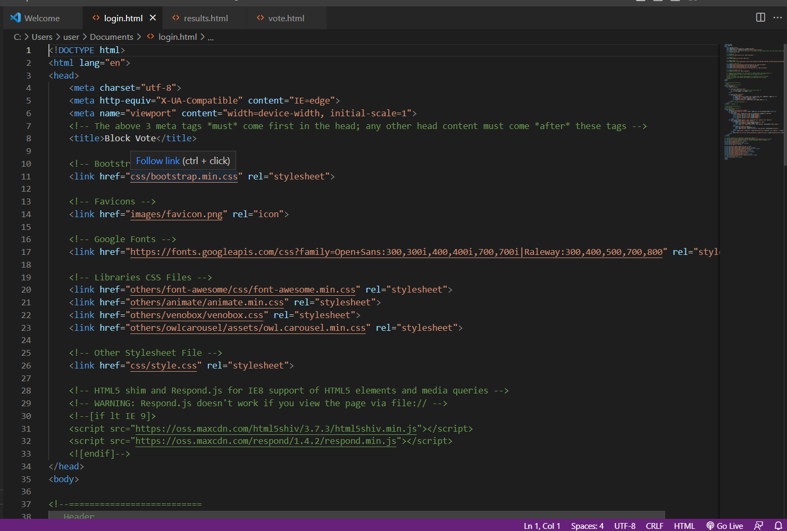

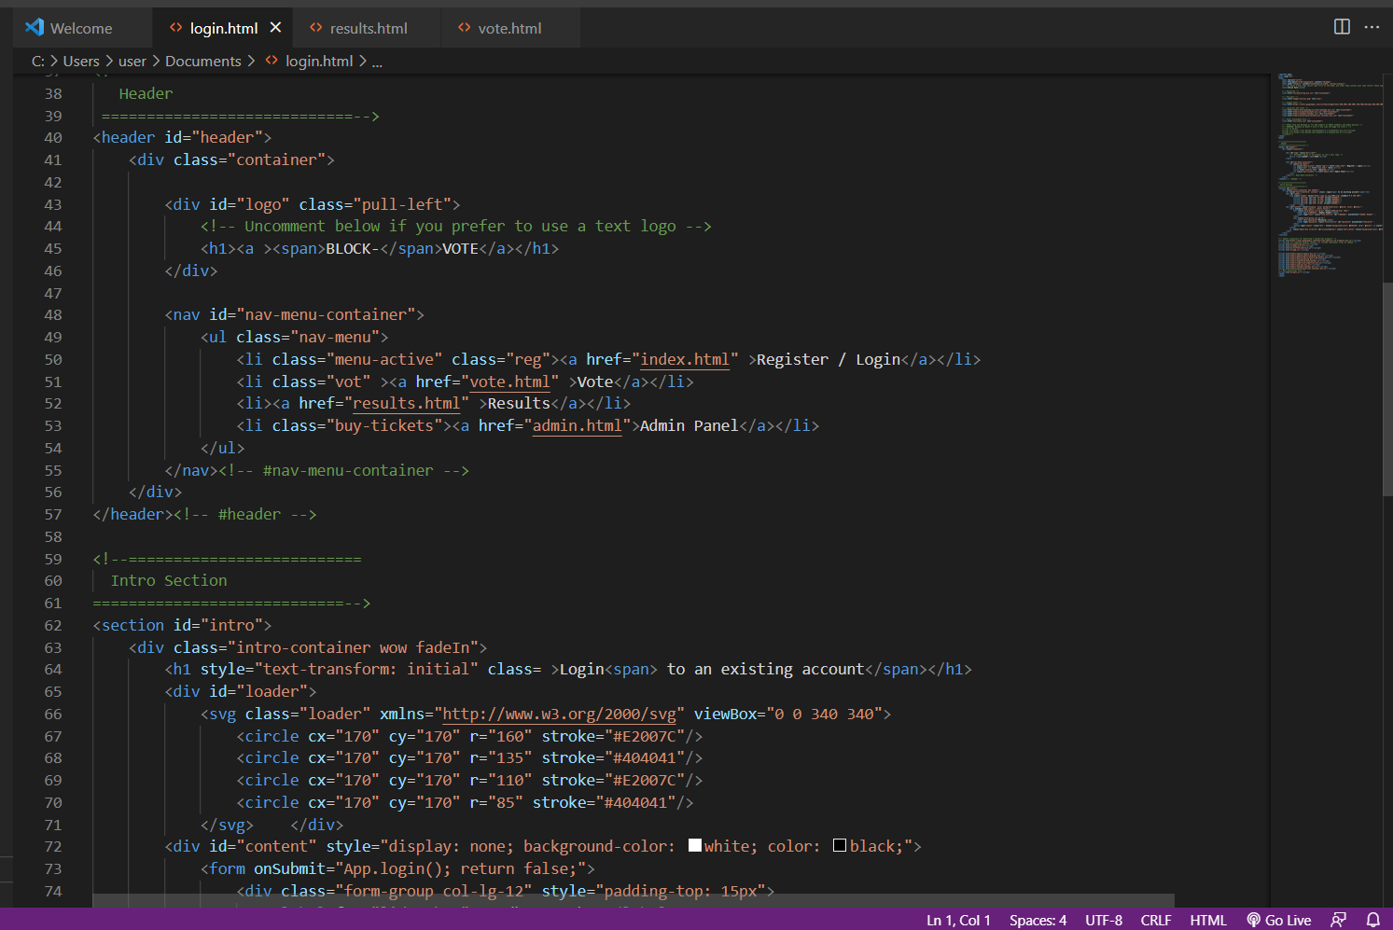

10.9: results.html

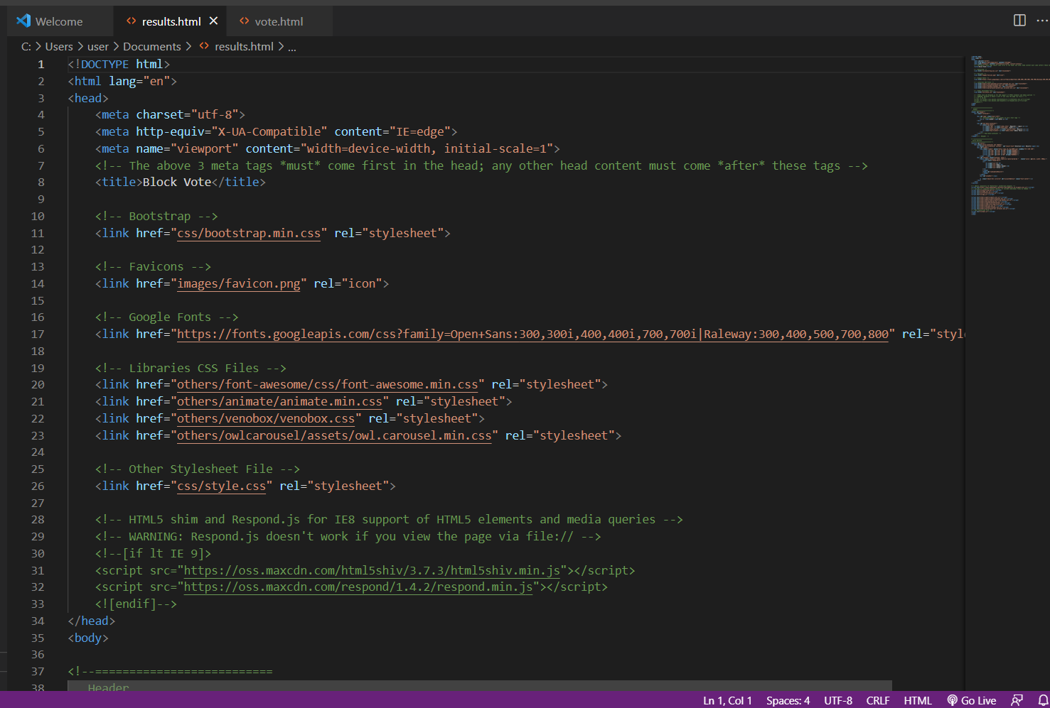

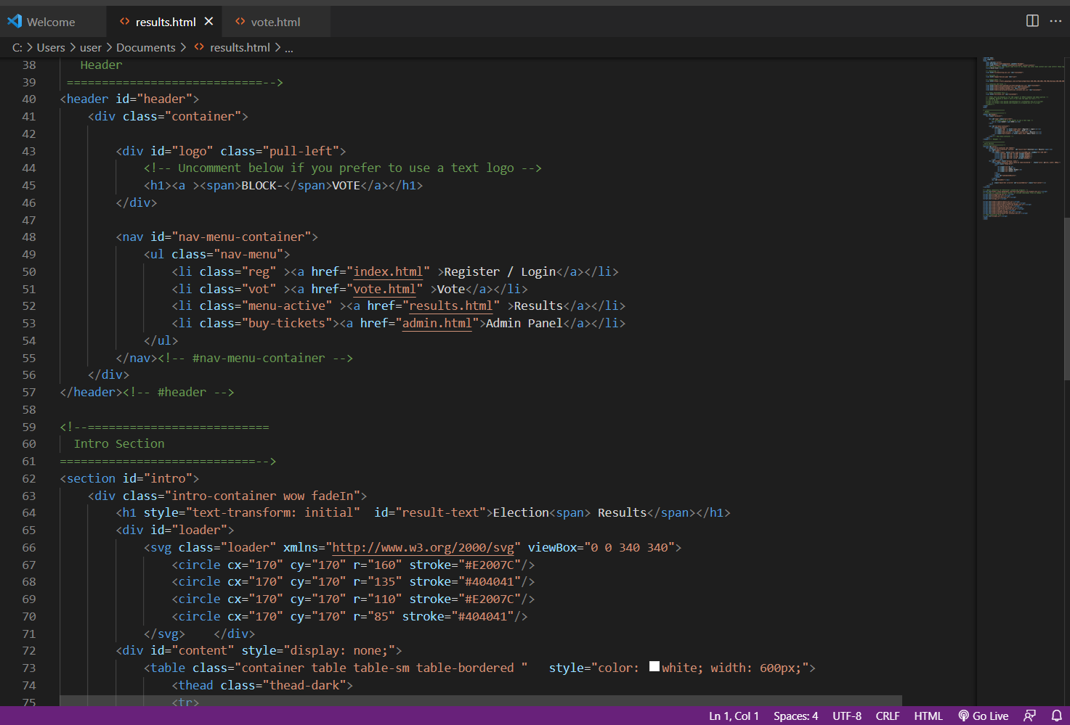

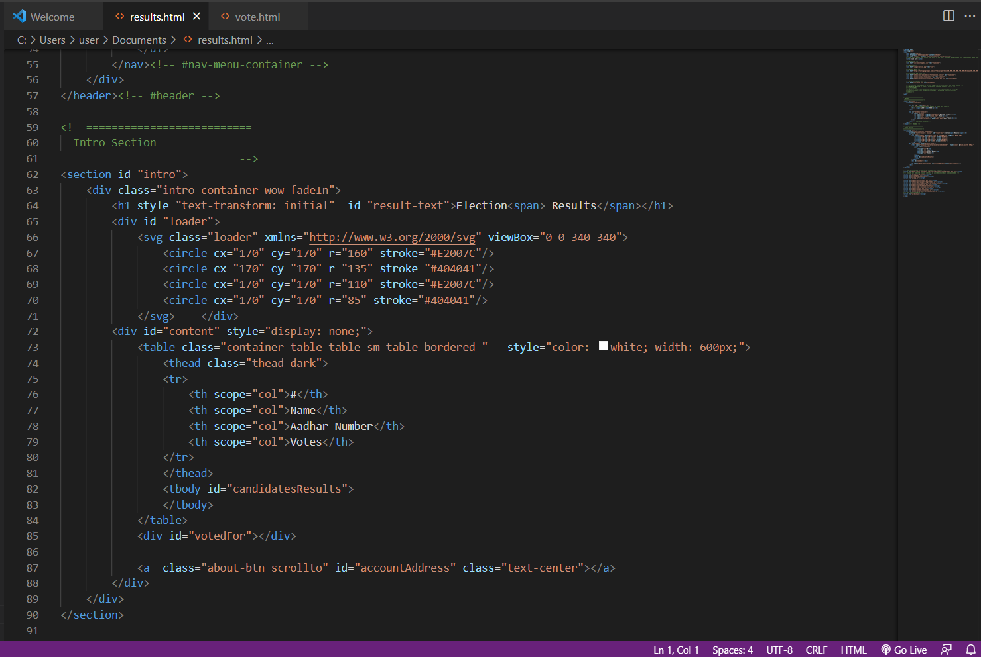

10.2: vote.html

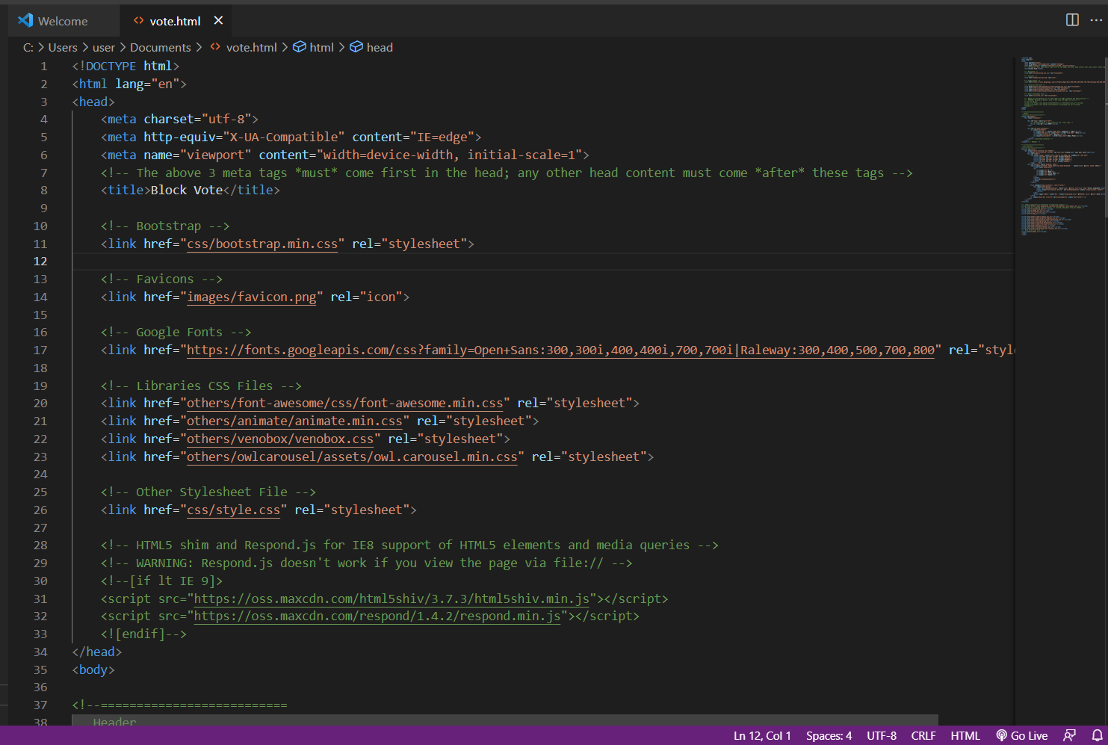

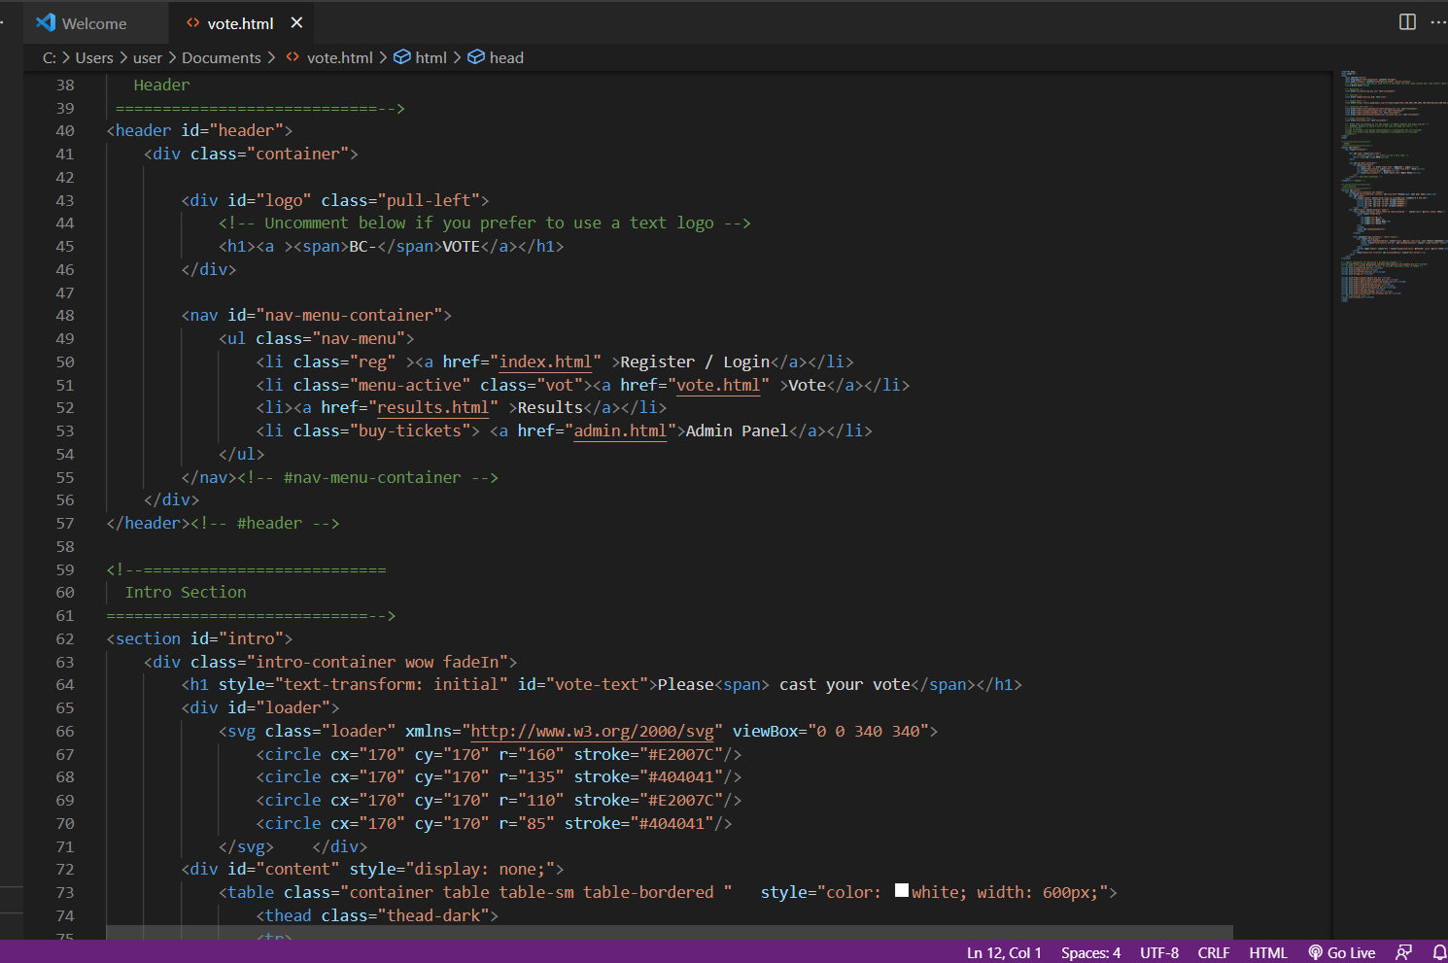

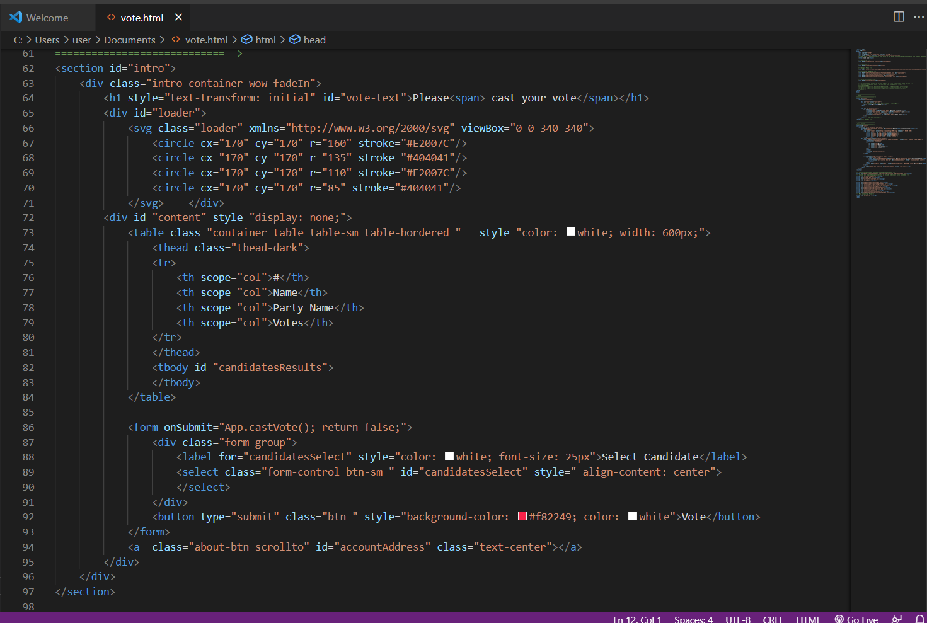

Chapter 11:

CONCLUSION

The concept of incorporating online voting systems to make the public election process cheaper, quicker, and easier is a compelling one in modern society. We have deployed online-based blockchain voting framework in this project where smart contracts are used to allow secure and cost-effective election while preserving the secrecy of the voters. Compared with previous research, we have shown that the blockchain technology provides a new opportunity for democratic countries to move from the pen and paper elect scheme and paperless direct-recording electronic voting machine (DRE) to a more cost effective and time-efficient election scheme, thus mounting the security measures of the current scheme, and offering new accessibility.

Chapter 12:

REFERENCES

* Adida B. and Rivest, R. L. (2006). Scratch & vote: Self-contained paper-based cryptographic voting, in Proceedings of the 5th ACM Workshop on Privacy in Electronic Society, ser. WPES '06. New York, NY, USA: ACM, 2006, pp. 29-40.
* Chaum, D., Essex, A., Carback, R., Clark, J., Popoveniuc, S., Sherman, A. and Vora, P. (2008) Scantegrity: End-to-end voter-variable optical- scan voting, IEEE Security Privacy, vol. 6, no. 3, pp. 40- 46, May 2008.